Working With Children Checks / VIT Registrations (2019 Template)
All staff, volunteers and committee members at your community language school must have a valid Working With Children Check (or VIT registration), regardless of whether they have regular student contact.
Please use this template to provide Check details (and card copies) for each staff member, volunteer and committee member at your school. The template and copies of the cards must be submitted as a single PDF called “07_workingwithchildren.pdf”.
Instructions:
- Please check through all the documents which you are submitting for accreditation, and make sure every staff member, volunteer and committee member who has been named in a document has a valid Working With Children Check, and has been included in this document.
- Please copy the details EXACTLY as they are shown on each of the cards.
- In the first column, please list the names in ALPHABETICAL ORDER according to the first letter of the first name mentioned on the card
- In the second column, please write down any other names by which a person is known at the school (for example, a name which might be used on a supervision schedule).
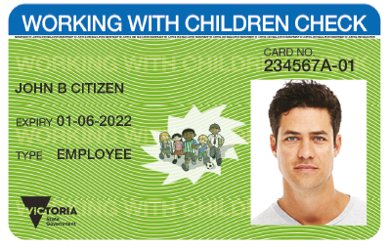
- At the end of the document, add clear, readable colour copies of the cards in the same order as they are listed in the table.
Sample of a Working With Children Check card. This is the information which you need to provide.

Full name  as it appears on the card | Other names  by which this person is known | Position in school | Campus | Working With Children Check |  | Victorian Institute of Teaching
 |  |  |  | Card Number | Card  Expiry Date | Registration Number | Registration Expiry Date
JOHN B CITIZEN | Johnny, Jono | Teacher | Carlton | 234567A-01 | 01-06-2022

Full name  as it appears on the card | Other names  by which this person is known | Position in school | Campus | Working With Children Check |  | Victorian Institute of Teaching
 |  |  |  | Card Number | Card  Expiry Date | Registration Number | Registration Expiry Date

